27.87: a) 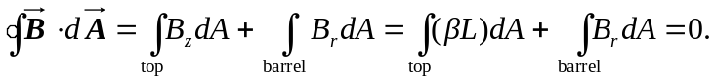
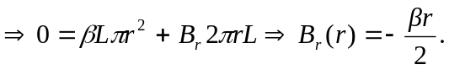
b) The two diagrams show views of the field lines from the top and side:

